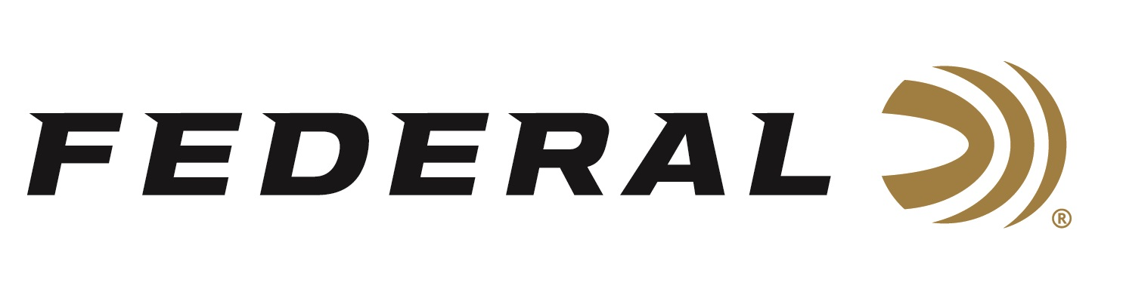

FOR IMMEDIATE RELEASE

Getting Packed Up on “It’s Federal Season” Podcast

ANOKA, Minnesota – March 18, 2021 – On this episode of the “It’s Federal Season” podcast, Federal Ammunition’s President Jason Vanderbrink welcomes a Minnesota mainstay in Duluth Pack’s CEO Tom Sega. This conversation is packed with discussions about the influx of new consumers, the demand for their company’s products, and the pride both companies have in building the best American made products for the outdoor enthusiast.

Episode #19 “Getting Packed Up”
https://www.federalpremium.com/this-is-federal/podcast/

According to Sega, Duluth Pack is the United States oldest canvas and leather pack, bag, and accessory manufacturer.

“Tom tells a great story of his nearly 140-year-old company,” said Jason Vanderbrink, President of Federal Ammunition. “His enthusiasm for the iconic brand and product category is refreshing and it’s great to talk about how Duluth Pack also crosses over to the shooting industry with premium handmade gun cases, range bags, and accessories for concealed carry.”

In addition to the fast paced conversation with Tom Sega at Duluth Pack, this episode takes a look back at a year of new production introductions from Federal and the accolades those innovations garnered from industry media partners.

For this episode, besides listening on your favorite podcast platform, you can also subscribe to Federal Ammunition’s YouTube channel and tune in for the discussion:
https://youtu.be/oP5drg-iK9w.

Federal Ammunition can be found at dealers nationwide or purchased online direct from Federal. For more information on all products from Federal or to shop online, visit www.federalpremium.com.

Press Release Contact: JJ Reich
Senior Manager – Press Relations
E-mail: VistaPressroom@VistaOutdoor.com

About Federal Ammunition
Federal, headquartered in Anoka, MN, is a brand of Vista Outdoor Inc., an outdoor sports and recreation company. From humble beginnings nestled among the lakes and woods of Minnesota, Federal Ammunition has evolved into one of the world's largest producers of sporting ammunition. Beginning in 1922, founding president, Charles L. Horn, paved the way for our success. Today, Federal carries on Horn's vision for quality products and service with the next generation of outdoorsmen and women. We maintain our position as experts in the science of ammunition production. Every day we manufacture products to enhance our customers' shooting experience while partnering with the conservation organizations that protect and support our outdoor heritage. We offer thousands of options in our Federal Premium and Federal® lines-it's what makes us the most complete ammunition company in the business and provides our customers with a choice no matter their pursuit.

